Name : Shrinivas Hatyalikar

Div: TY-B (B2)

Roll No: 26

# Q) Josephus Problem

Part 1 : Array Implementation

Code:

#include <stdio.h>

int josephus(int n, int k) {

    // Create an array to represent the circle of people

    int circle[n];

    for (int i = 0; i < n; i++) {

        circle[i] = i + 1;

    }

    // Initialize the starting index (position) as 0

    int index = 0;

    // Iterate until there's only one person left in the circle

    while (n > 1) {

        // Calculate the index of the person to be removed

        index = (index + k - 1) % n;

        // Remove the person from the circle by shifting elements

        for (int i = index; i < n - 1; i++) {

            circle[i] = circle[i + 1];

        }

        // Decrement the number of people in the circle

        n--;

    }

    // Return the position of the last remaining person

    return circle[0];

}

int main() {

    int n = 0;  // Number of people in the circle

    int k = 2;  // Step size to count (the k-th person will be removed each time)

    printf("Enter the number of People: ");

    scanf("%d",&n);

    int result = josephus(n, k);

    printf("The last remaining person's position is: %d\n", result);

    return 0;

}

Output:

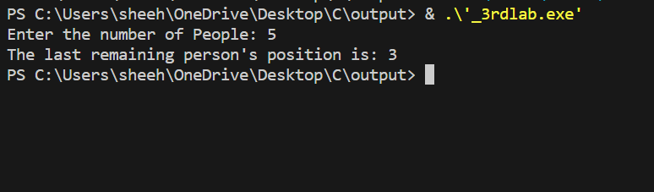

Part 2 : Circular Queue Implementation

Code:

#include <stdio.h>

#include <stdlib.h>

struct Node {

    int value;

    struct Node* next;

};

struct Node* createNewNode(int value) {

    struct Node* newNode = (struct Node*)malloc(sizeof(struct Node));

    newNode->value = value;

    newNode->next = NULL;

    return newNode;

}

void addToQueue(struct Node** rear, int value) {

    struct Node* newNode = createNewNode(value);

    if (*rear == NULL) {

        *rear = newNode;

        (*rear)->next = newNode;

    } else {

        newNode->next = (*rear)->next;

        (*rear)->next = newNode;

        *rear = newNode;

    }

}

int removeFromQueue(struct Node** rear) {

    if (*rear == NULL)

        return -1;

    struct Node* front = (*rear)->next;

    int value = front->value;

    if (front == *rear) {

        free(front);

        *rear = NULL;

    } else {

        (*rear)->next = front->next;

        free(front);

    }

    return value;

}

int findWinningPerson(int n) {

    struct Node* rear = NULL;

    for (int i = 1; i <= n; i++) {

        addToQueue(&rear, i);

    }

    while (rear->next != rear) {

        int firstPerson = removeFromQueue(&rear);

        int secondPerson = removeFromQueue(&rear);

        addToQueue(&rear, firstPerson);

    }

    int winningPerson = rear->value;

    free(rear);

    return winningPerson;

}

int main() {

    int n = 0;

    printf("Enter number of persons: ");

    scanf("%d",&n);

    int winner = findWinningPerson(n);

    printf("Using Circular Queue\n");

    printf("The last remaining person's position is: %d", winner);

    return 0;

}

Output:

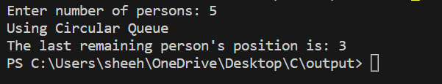

Part 3 : Recursion Implementation

Recurrance Relation:

f(n) = Winners position when the total no. of people = n f(n) -> 2 f(j) – 1 n:even , n=2j

-> 2 f(j) + 1 n:odd , n=2j+1

Code:

#include <stdio.h>

int remain[1000]; // Assuming n <= 1000, adjust the array size as needed

int findremaining(int n) {

    if (n == 1) {

        return 1;

    }

    if (remain[n] != -1) {

        return remain[n];

    }

    int j;

    if (n % 2 == 0) {

        j = n / 2;

        remain[n] = 2 * findremaining(j) - 1;

    } else {

        j = (n - 1) / 2;

        remain[n] = 2 * findremaining(j) + 1;

    }

    return remain[n];

}

int main() {

    int n;

    printf("Enter number of persons: ");

    scanf("%d", &n);

    for (int i = 0; i <= n; i++) {

        remain[i] = -1; // Initialize the memoization array

    }

    int remain = findremaining(n);

    printf("Using Recurssion\n");

    printf("The last remaining person's position is: %d\n", remain);

    return 0;

}

Output:

